Building and Editing User Experiences in Workday
Updated 3.21.25 by Kristina Kelpe

There are two primary ways to design a user navigation: Hubs and Dashboards. Workday owns the Hubs and determines the content. Custom items often don’t show up well. Custom Dashboards can be completely customized. Workday delivered dashboards can be customized, but are limited to one tab. It is recommended to create custom dashboards so that you have more flexibility. Dashboards can be for end users like Students but also are very useful for Staff to organize their tasks and reports.

Student Dashboard Example
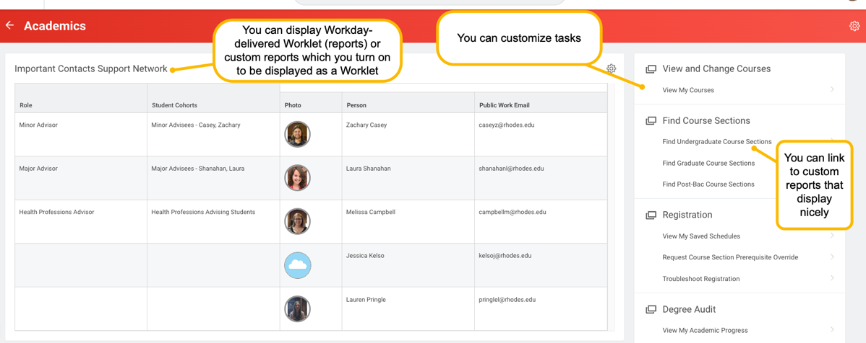

Student Hub Example
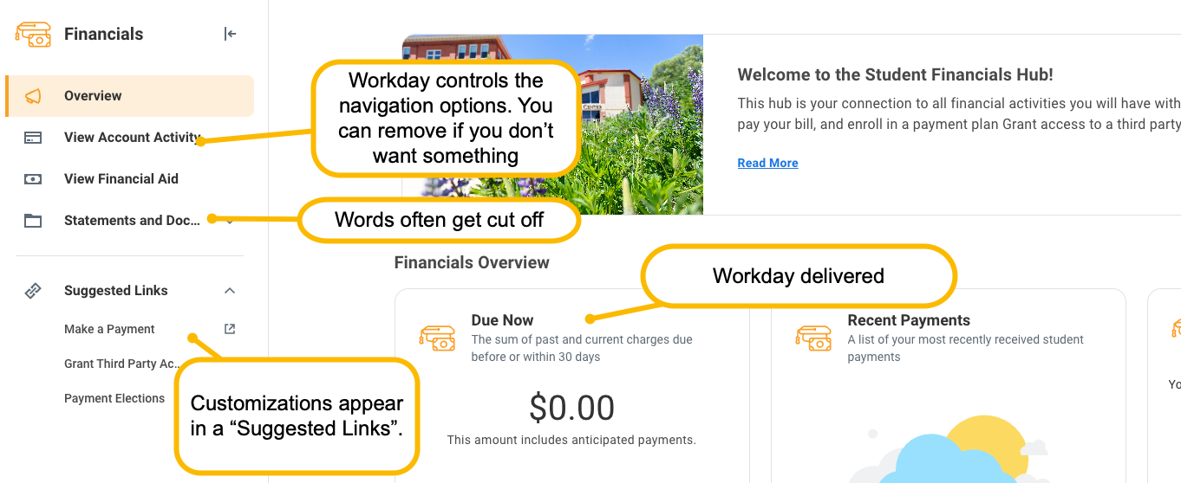
FAQs
Question: What is a Worklet?
Answer: A small, customizable widget or application that provides quick access to specific information or tasks. Worklets are typically displayed on a user’s Workday home page and allows users to interact with Workday data or functions in a simple, efficient manner without having to navigate through multiple menus. Workday uses the word “worklet” interchangeably and sometimes it has other names. Sometimes I feel like it could also be called a “thingamajig” because its name is not consistent. In essence, worklets improve productivity.
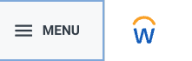
Question: What do you call the left-hand navigation?
Answer: It has changed names over time (worklet, dashboard, app). As of the 2025R1 release, it no longer has a label for users. It just appears in the Menu.

Creating and Managing Dashboards
To do this, follow these steps:
- Get security to be able to build dashboards

- Go to the task: Create Custom Dashboard (make sure to pick an icon that makes you happy).

- Go to the task: Maintain Dashboards. Find your dashboard and click Edit.

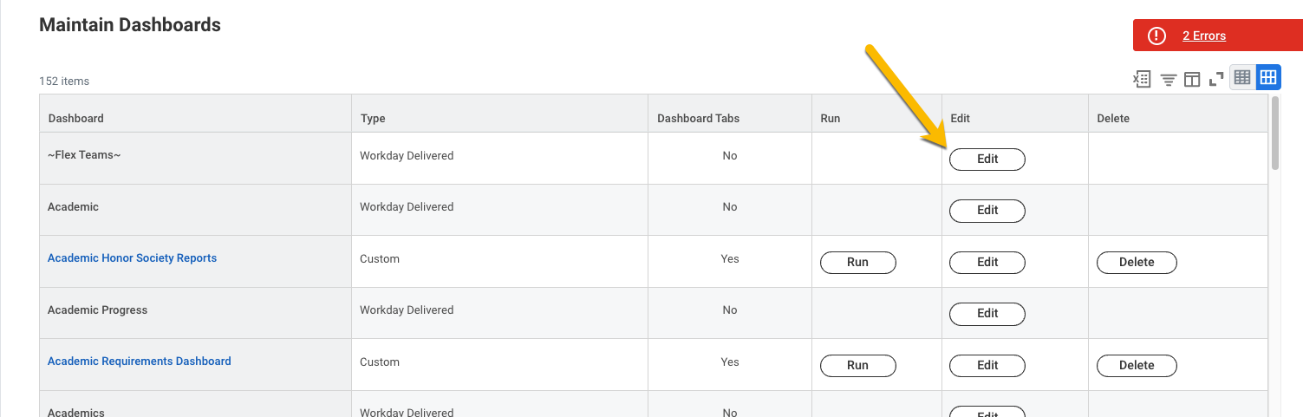

- On the Content tab, click Add.

- Pick a name for your first tab. Don't worry too much about it. You can always change it later.

- Under the Menu section, click the + sign. Give your section a label. This is where I like to give names that people may recognize (e.g. Degree Audit). Then when you can't remember that task in Workday this section label can guide you to the task related to that topic.

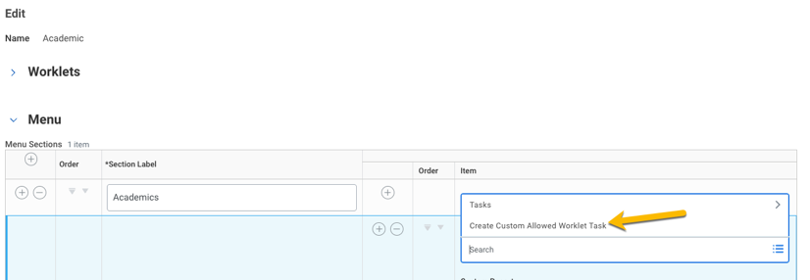
- Most of the time to add a task, you need to select Create Custom Allowed Worklet Task. Make sure to select the one associated with the right task for administrators and not one designated for students or instructors. It’s typically NOT recommend to use the Add Custom Name option. While it can seem helpful, as people learn the system and may just want to type the task in the search bar the custom name will not return results. It's best to learn the Workday name.

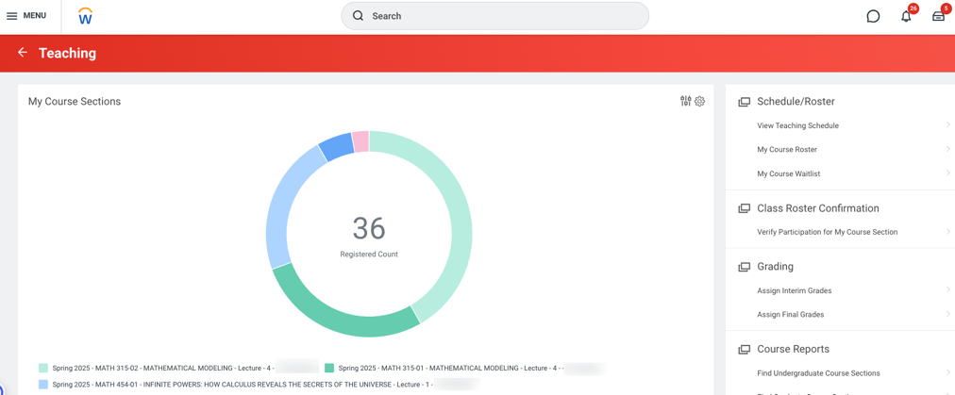
- (Optional) Use an excellent report writer to design a cool visual report that you can add in the Worklet's section. Reporting is the biggest benefit of Workday. Seeing a report that is easy to digest and helpful reminds you of why you're making this investment to change to a new system.

Configure Global Navigation

Workday enables you to design the organization of all the dashboards (apps).
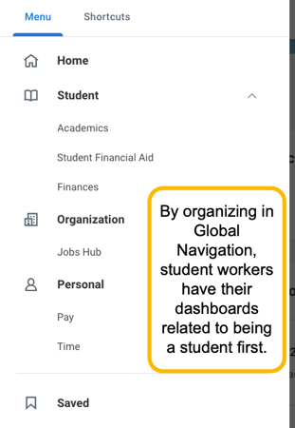
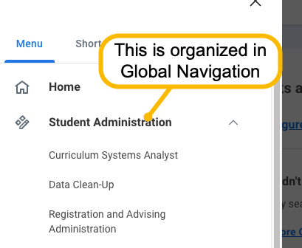

- You can get to the Global Navigation set-up two ways:
  - Go to Maintain Dashboards and select Global Navigation from the Hub
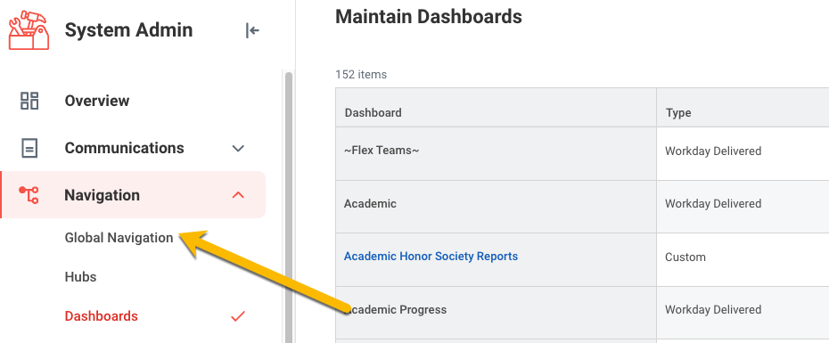
  - Go directly to the task: Configure Global Navigation
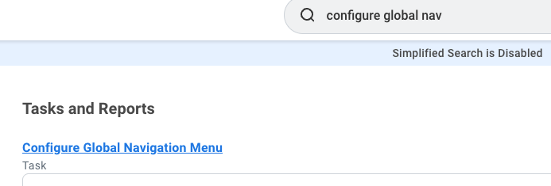
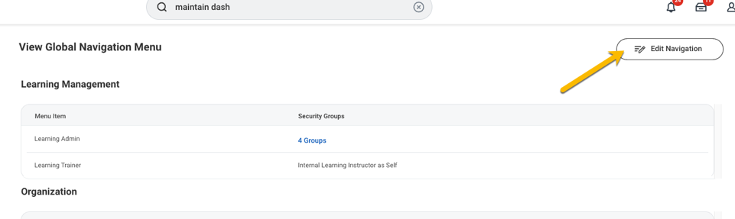
- Click on Edit Navigation

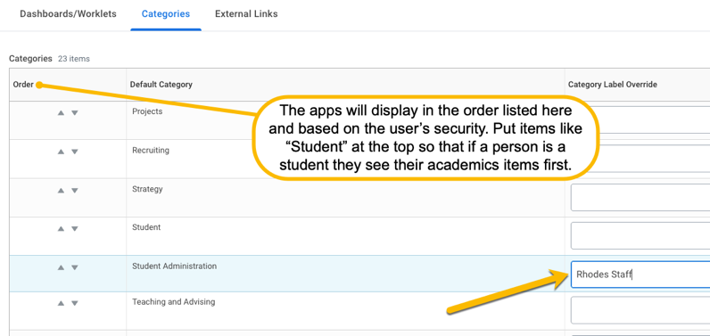
- Click on the Categories section. Set your category labels. This is what will display to users on the left hand navigation bar as a header with the dashboards/apps below it. Confirm across HCM/FIN/Student which categories each product area wants to use.

- Go to the Dashboards/Worklets tab. Customize which category the dashboard should go into. Even if you have used a label, the original category name will display here.

You can organize the Category Override. You can no longer set the order that the dashboards (apps) display. Dashboards only display in alphabetical order within the category.
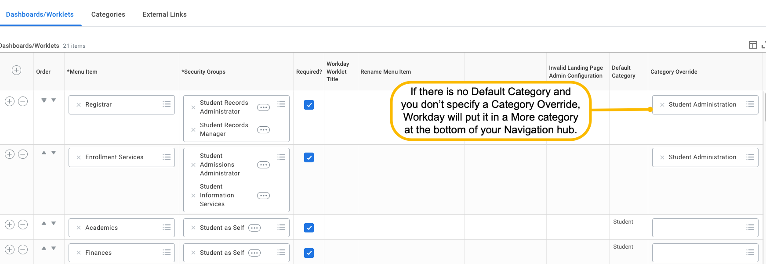

Adding a Workday-Delivered Worklet to Custom Dashboard
Workday creates delivered worklets. If you have a custom dashboard, you must enable a Workday-delivered worklet to appear.
- Access the Enable Worklet for Dashboards task.
- Select the worklet and select the dashboard you created.
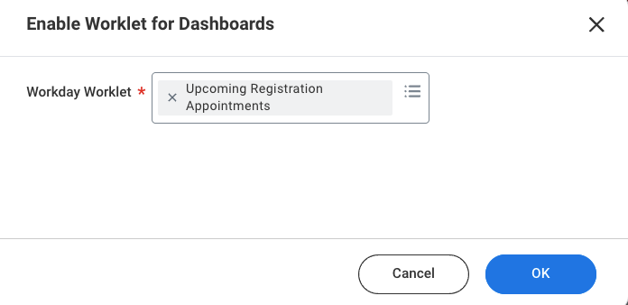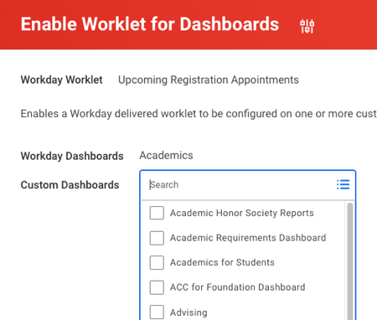

Adding an Announcement to a Dashboard
- Go to the task Maintain Dashboards
- Find the dashboard and click Edit
- Go to the Announcements tab. Click the + sign.
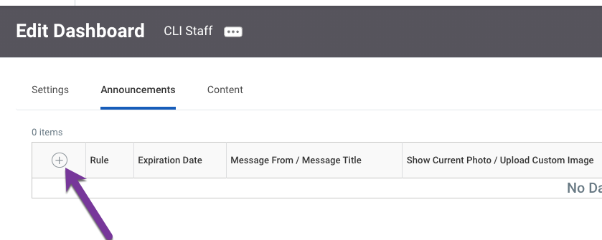
- If you want conditional logic for it to show, add a rule. Add an expiration date if you want one. If you want to just put a permanent message, go to the Message section and enter the announcement there.
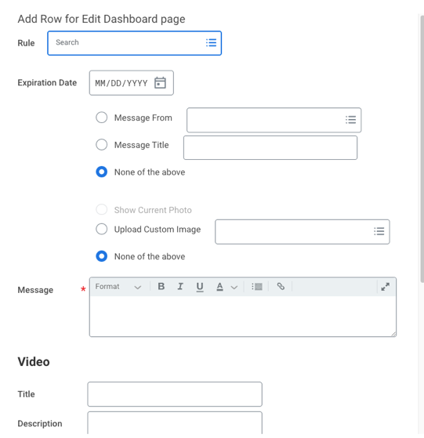
- There are many other options you have on the announcements section that you can play around with until you get your announcement the way you want it.

Creating and Managing Bulletin Worklets
A visually appealing way to display information to students is using the bulletin functionality. One of the best pieces is that in the rules, you have more options to customize who sees the information. In this way you can have announcements for graduate students only show to graduate students. Or you can customize the Find Graduate Course Sections lookup report only appear to graduate students.
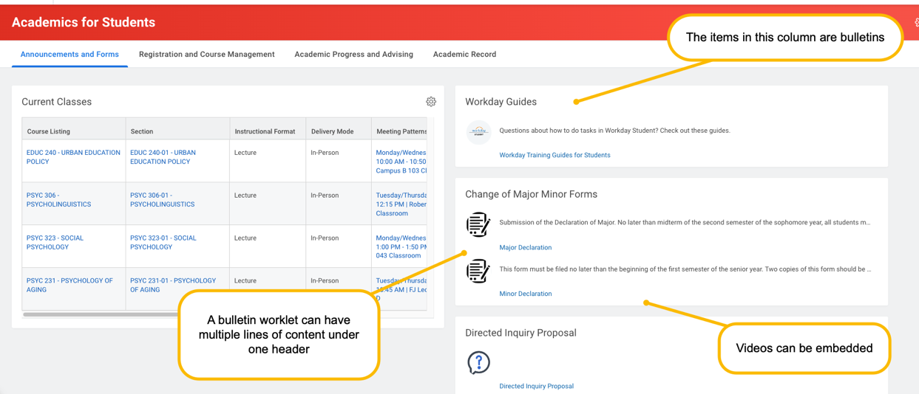
- Go to: Create Bulletin Worklet
- Follow the below image to understand each aspect:
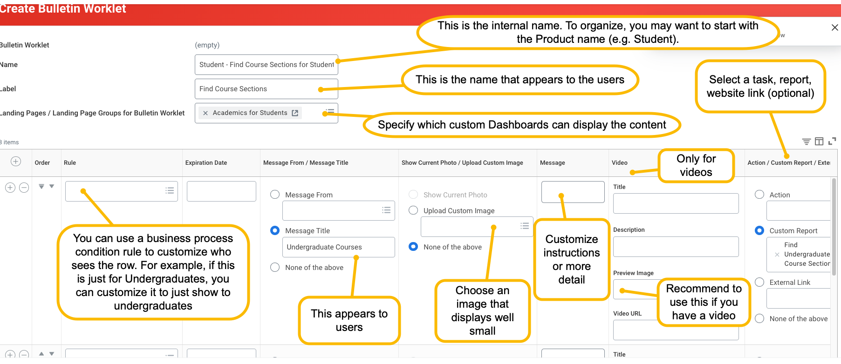
- Go to Maintain Dashboards and select the custom dashboard that you put as the Landing Page.
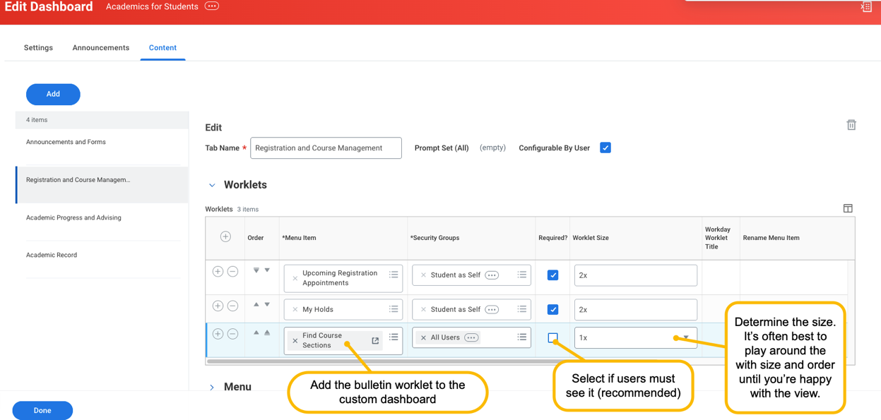
- Proxy as a user that meets the rules/security to confirm view. Adjust as needed.
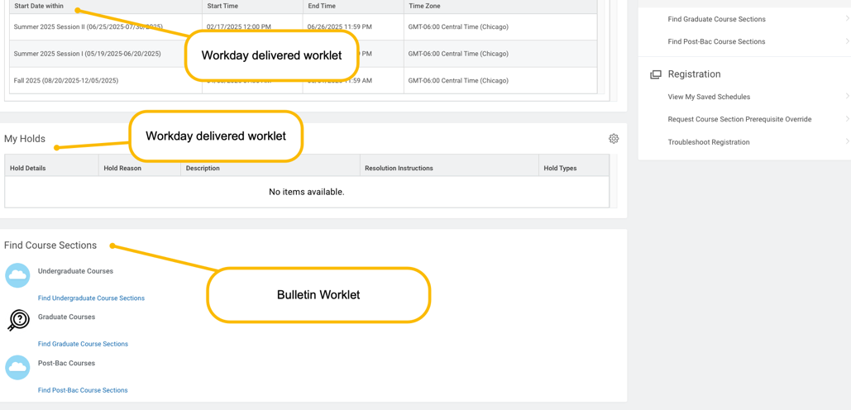

Maintaining Hubs
- Set up security for hubs. More information is posted here:
https://doc.workday.com/admin-guide/en-us/student/student-data/student-hubs/bcv1626124859772.html
- Go to the task Maintain Hubs
- Use the Action button to configure.
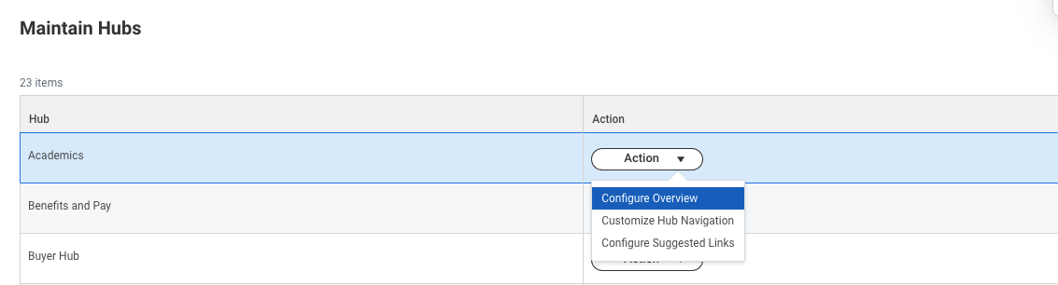

- On the Configure Overview, these are the worklets that display on the middle of the page.
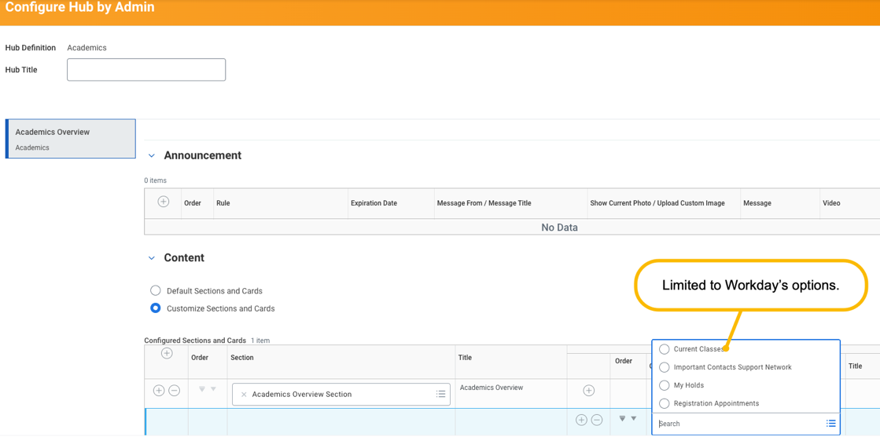
- You can customize the Navigation items Workday provides in the Hubs.
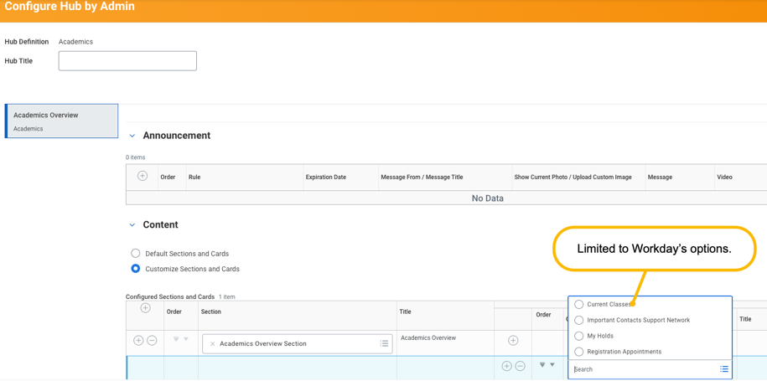
- In the Configure Suggested Links, you can add custom tasks/reports. If you add the dashboard, it allows students to return to that dashboard in the navigation.
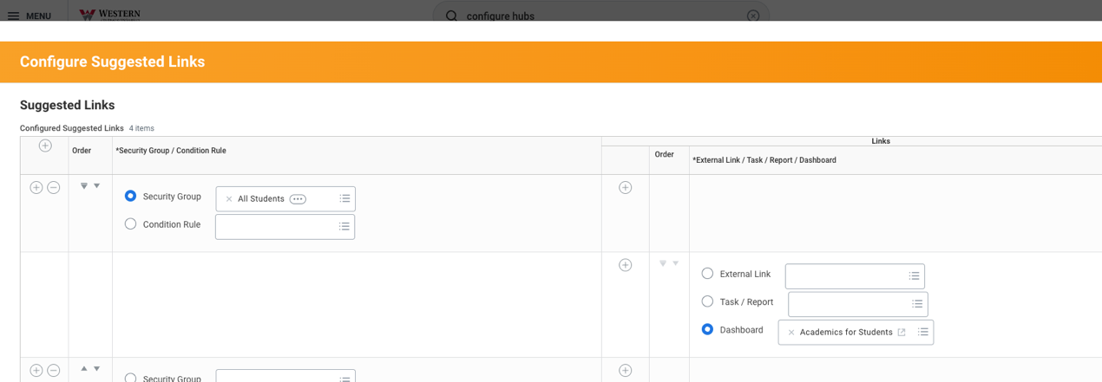
- If you want the hub to appear in the left-hand navigation, you need to add it to the Global Navigation Menu as a Dashboard/Worklet.
